**PRACTICAL 1**

**Import the legacy data from different sources such as ( Excel , SqlServer, Oracle etc.) and load in the target system. ( You can download sample database such as Adventureworks, Northwind, foodmart etc.)**

**Step 1: Open Sql Server Data Tools.**

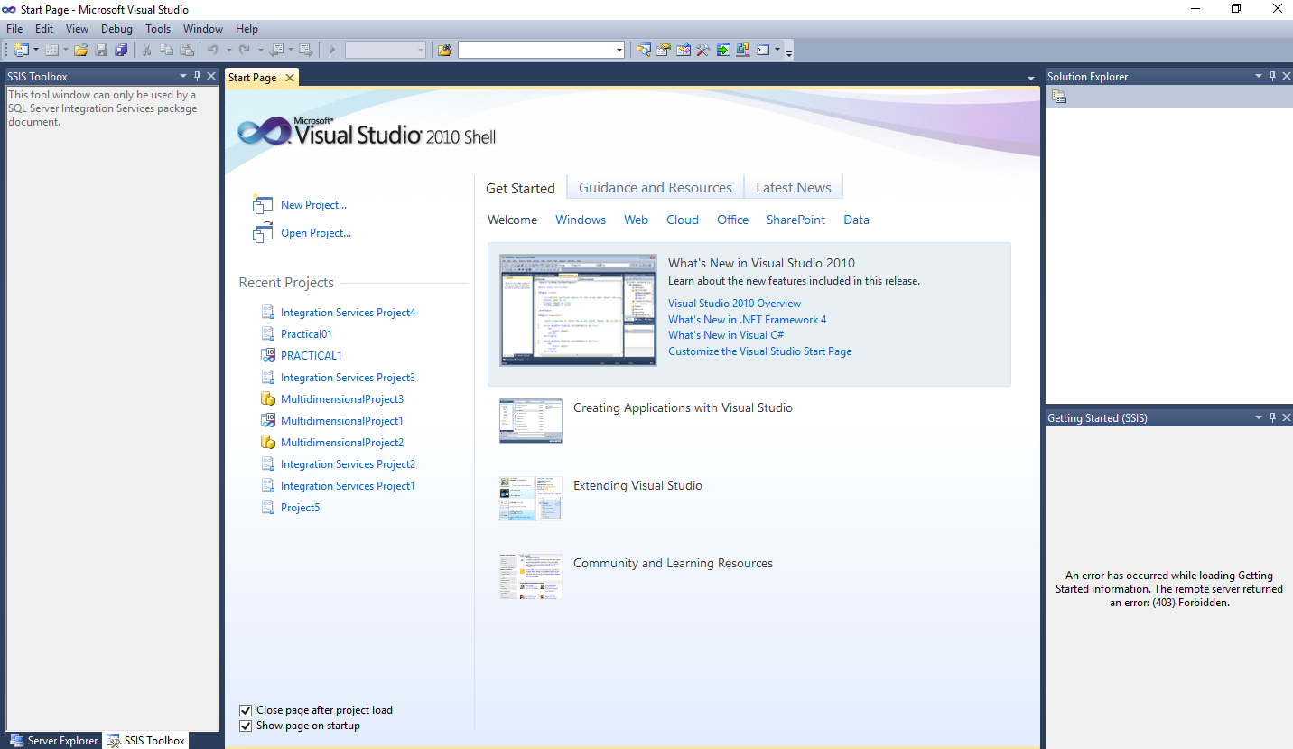

**Step 2: click on New Project and Select Integration Services Project and click on Ok.**

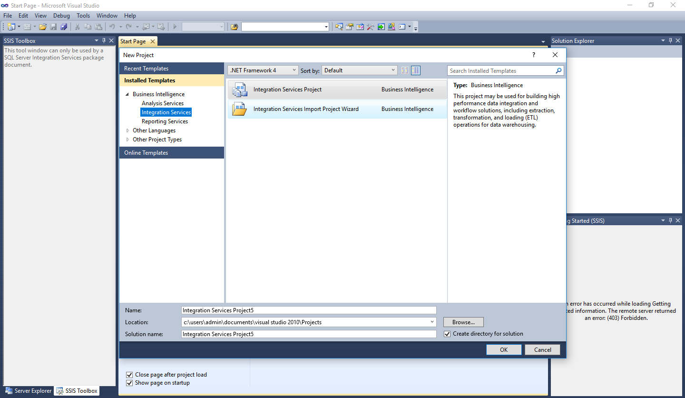

Step 3: Open This Window then Select Data Flow Task from SSIS Toolbox.

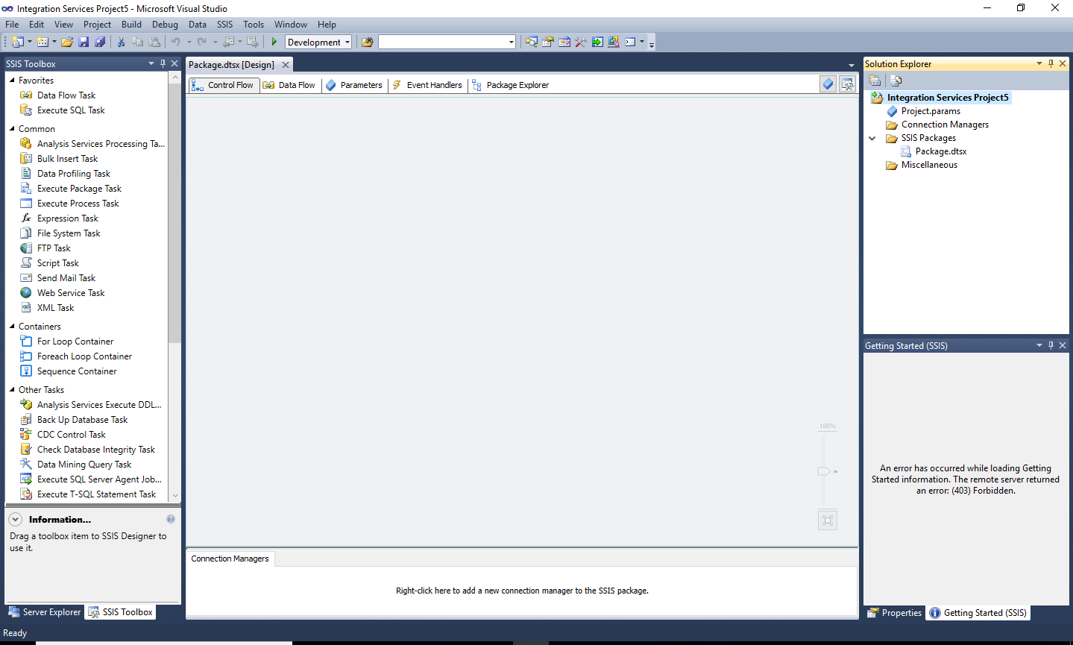

Step 4: Drag and Drop 2 Data Flow Task and rename as Source and Destination. After that connect it.

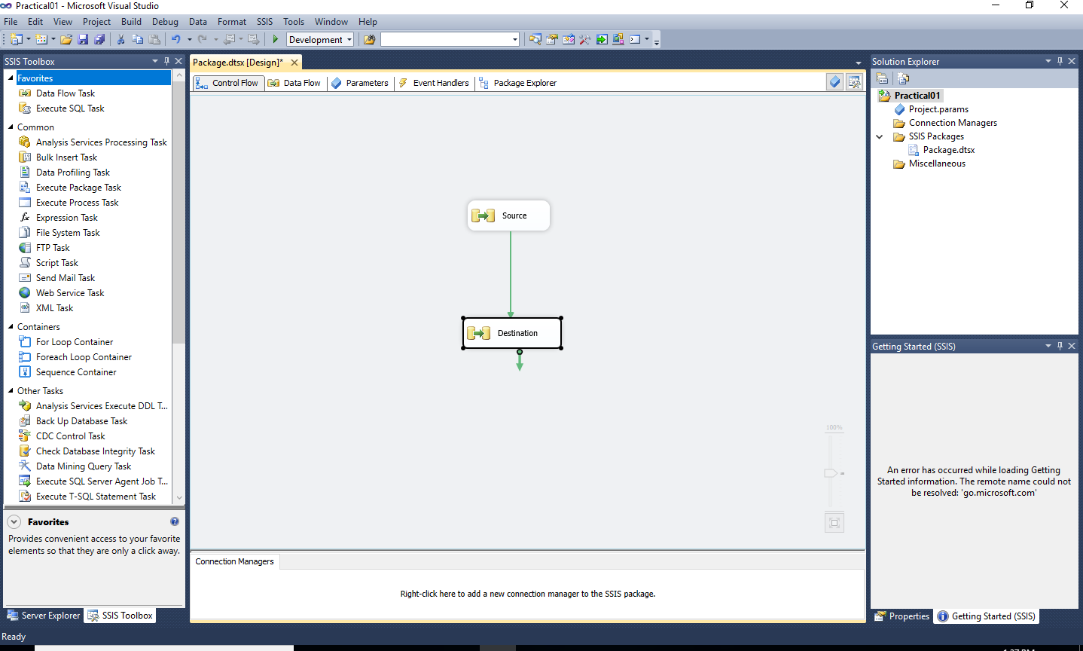

Step 5: Drag and Drop Source as OLE DB Source and Destination as Excel Destination from SSIS Toolbox.

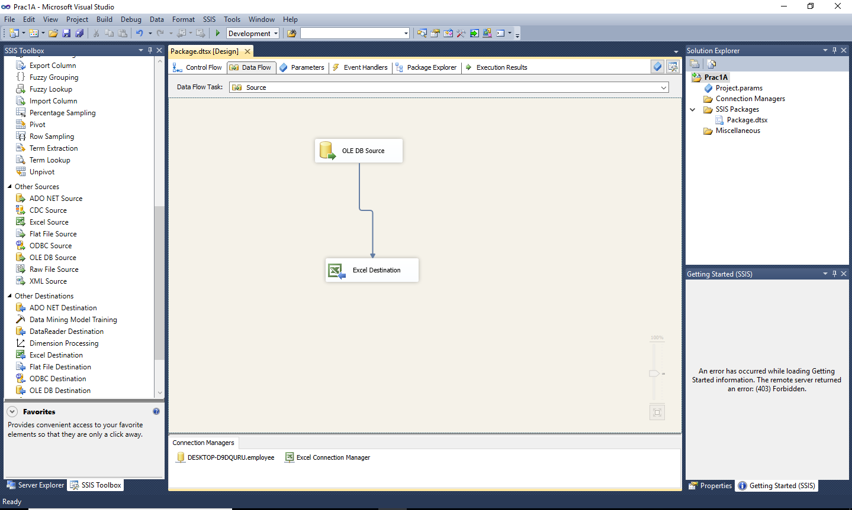

Step 6: Create new excel file with same column as OLE DB Source.

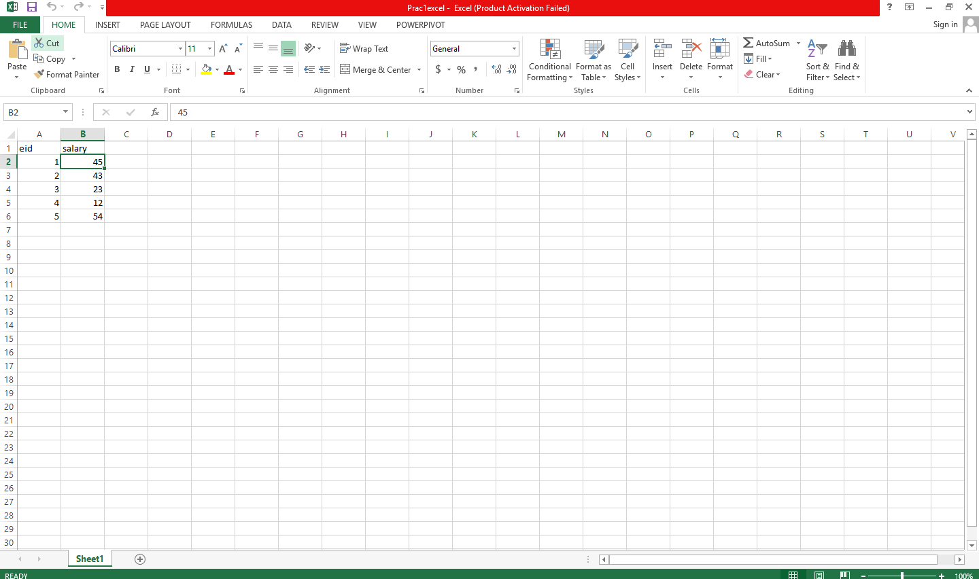

Step 7 : Double Click on OLE DB Source.

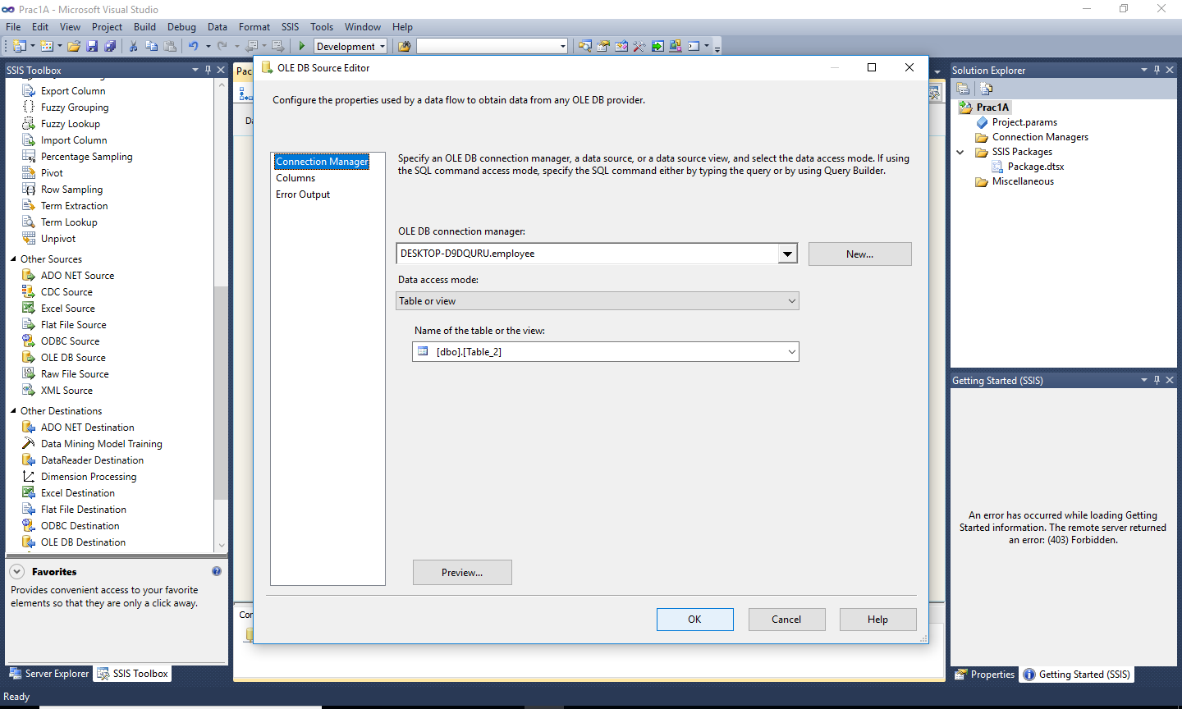

step 8:Select Data Connections file and Click on OK

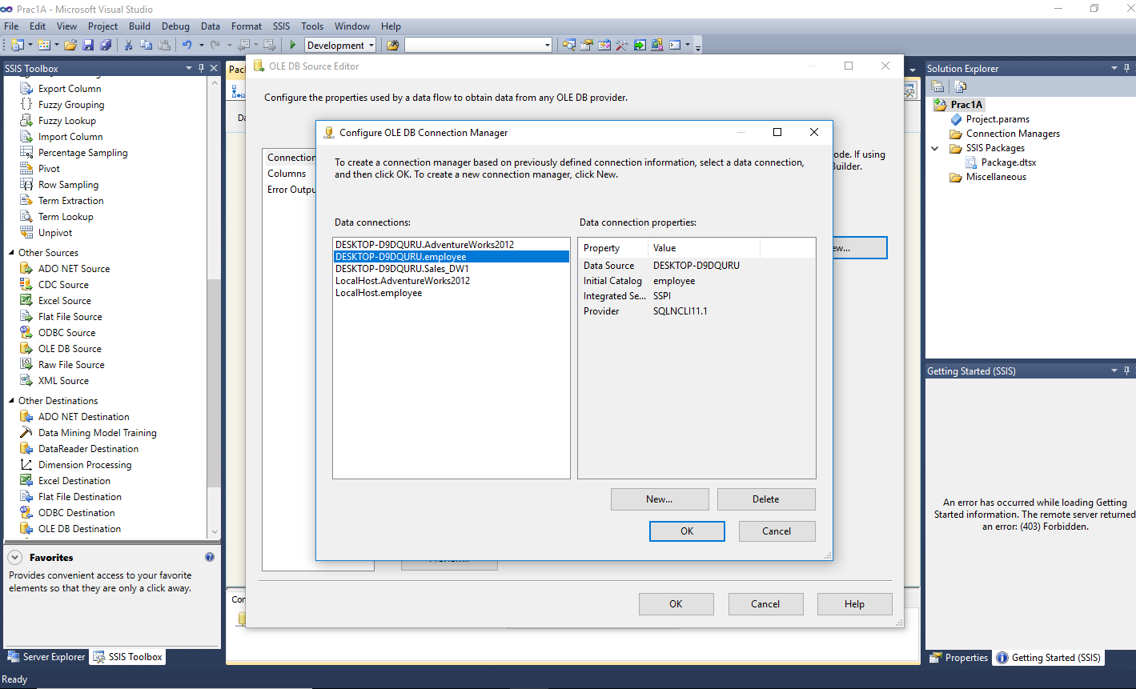

step 9:Select the (Name of the table or the view) from dropdown list

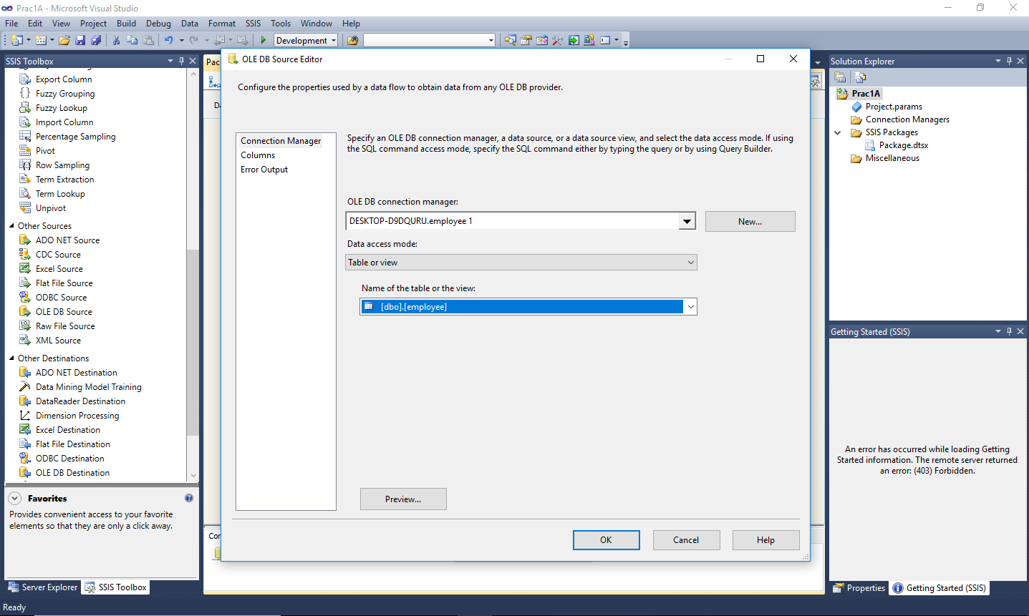

step 10:Click on Preview(show existing data in the table) then click on Close.

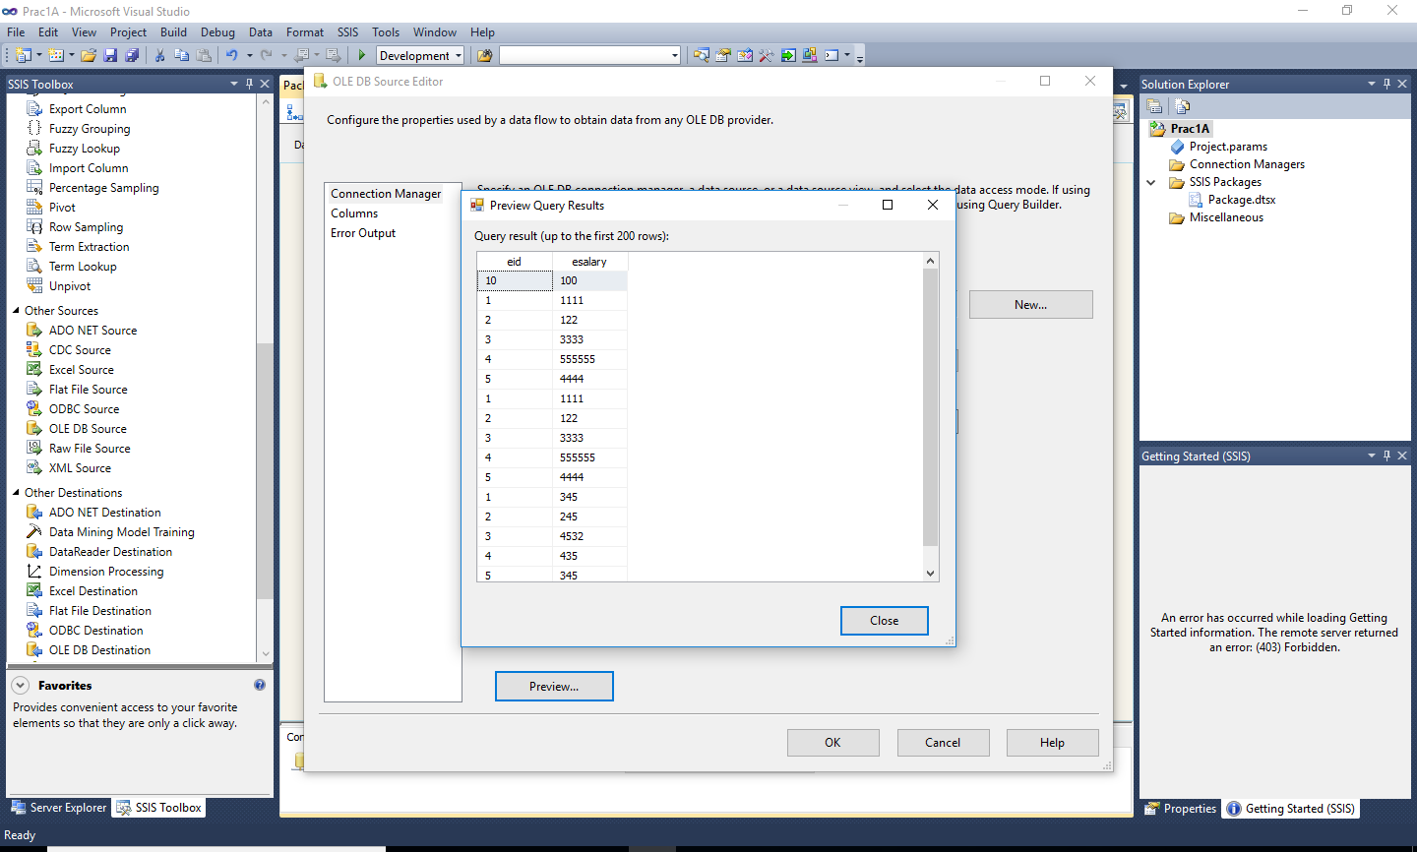

Step 11:Click on Columns, Match the External Columns with Output Columns and then click on OK.

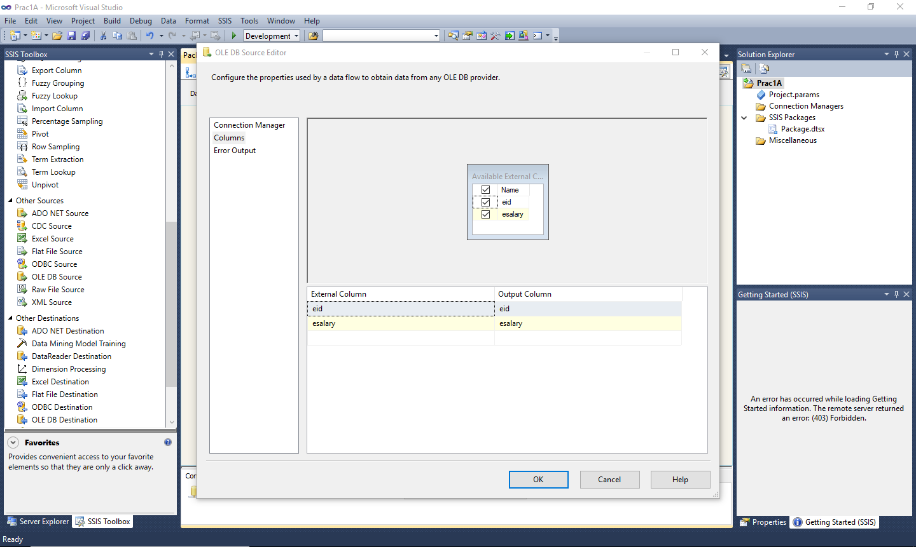

Step 12: Double click on Excel Destination then click on New Button.

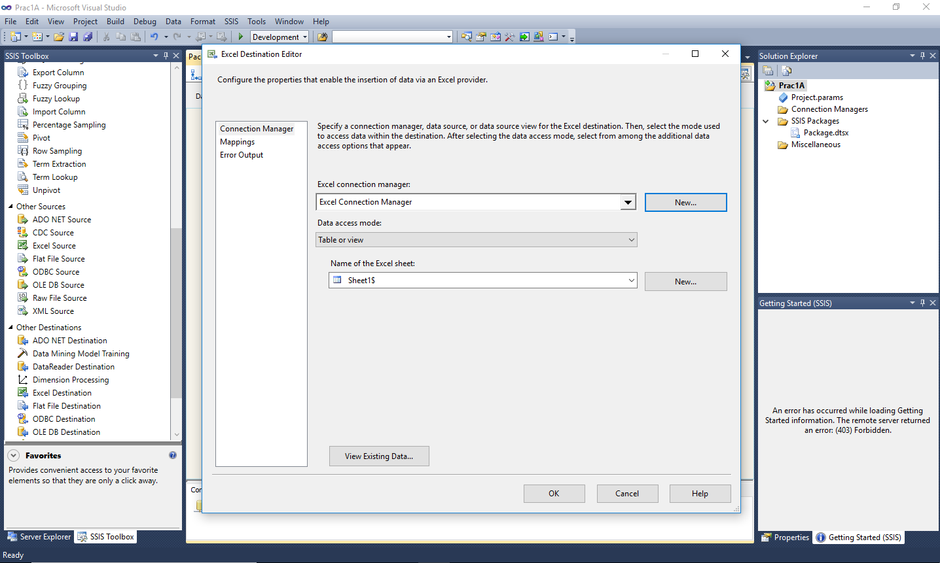

Step13: Click on Browse and select previously saved excel file and click on Ok.

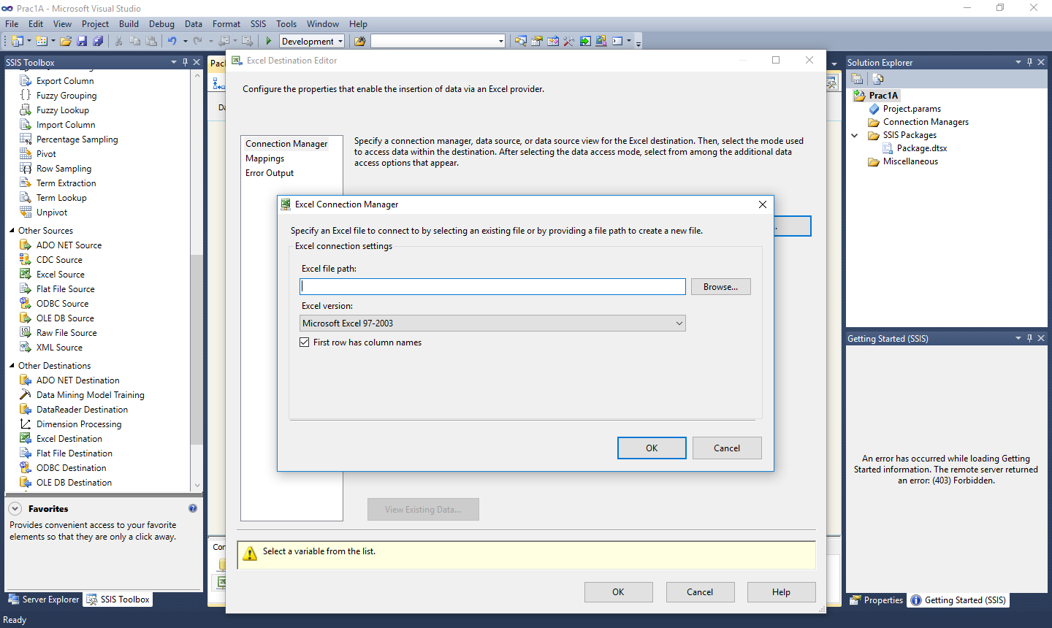

Step 14:Select Name of the Excel sheet from dropdownlist.

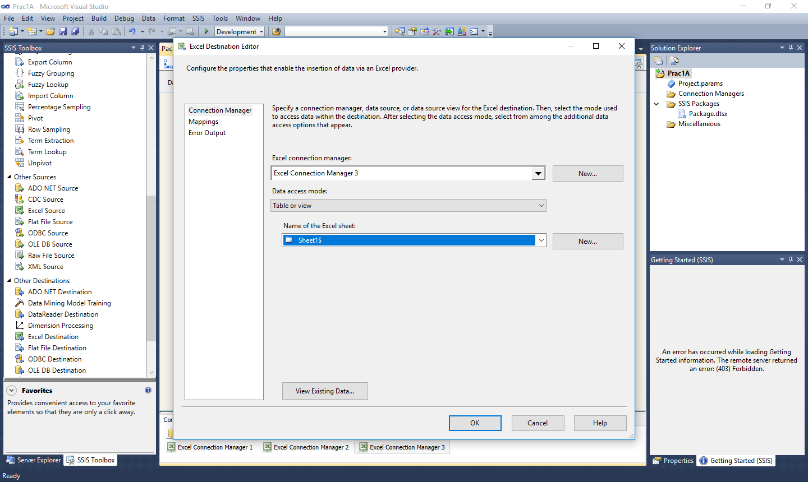

Step 15:Click on Mappings and match the Input Column with Destination Column and click on OK.

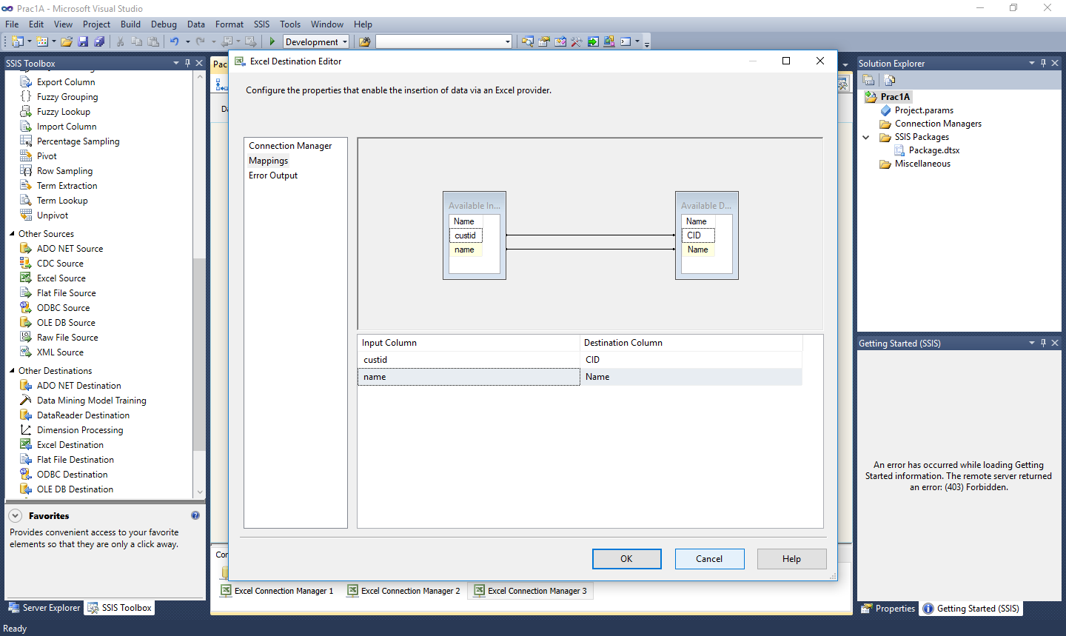

Step 16:Right click on project name from solution explorer and click on properties -->configuration properties-->Debugging-->Debug Options -->Run64BitRuntime as false then click on ok.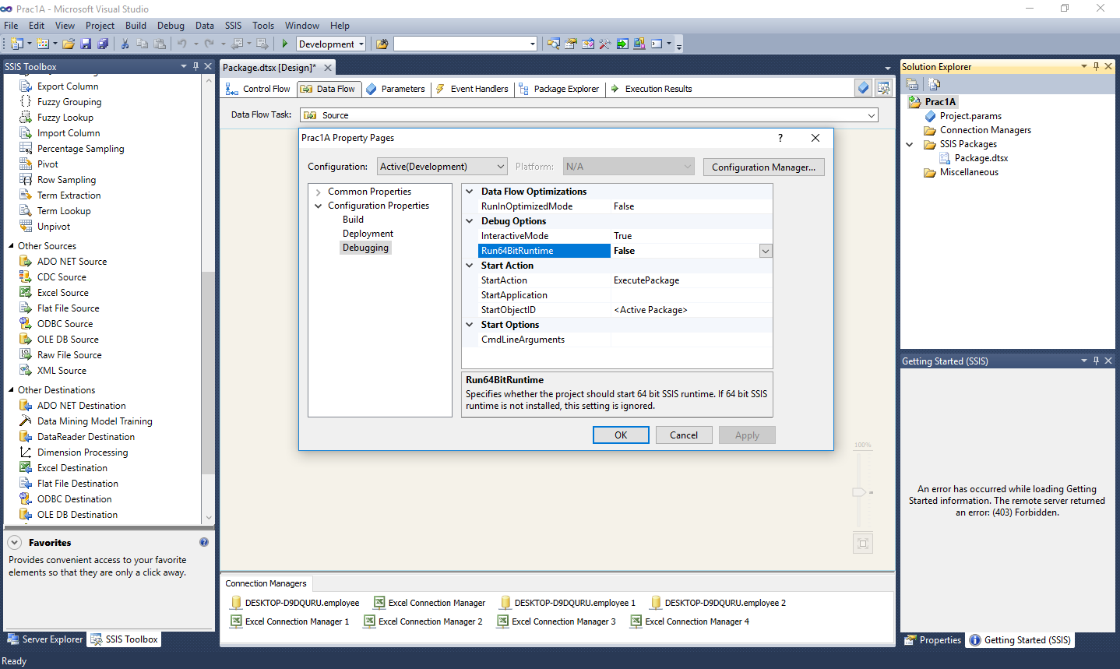

Step 17: Run the Project.

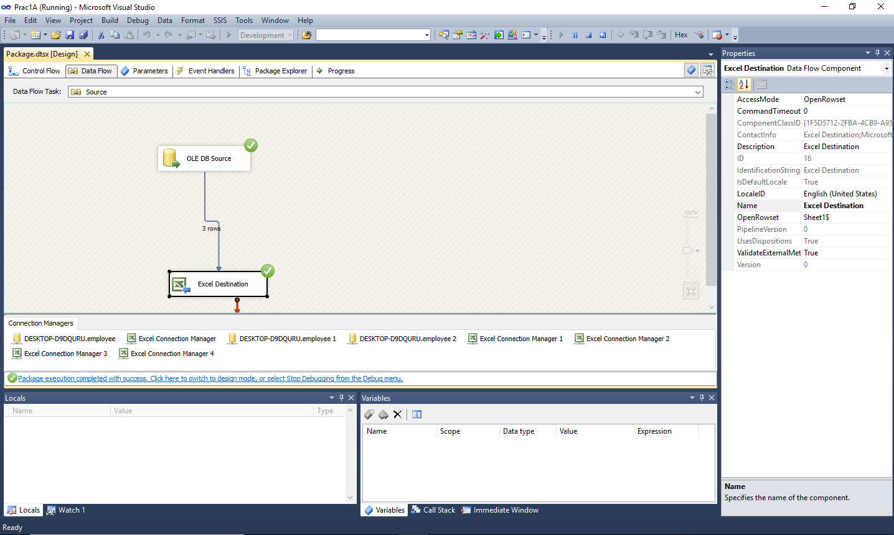

Step 18:See Changes in the excel file

